Pre-vocational training

Unit 2

Being a fitness instructor

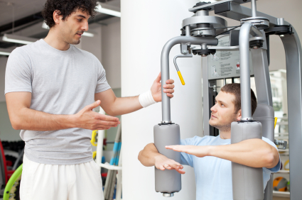

Contents

Unit 2 Working as a fitness instructor: teachers’ notes

Unit 2 Working as a fitness instructor: answers

Unit 2 Working as a fitness instructor: transcripts

Unit 2 Working as a fitness instructor: classroom materials

Unit 2 Working as a fitness instructor: TP_PreVocU2_FitnessIns_A
TP_PreVocU2_FitnessIns_B
TP_PreVocU2_FitnessIns_C
TP_PreVocU2_FitnessIns_D

Copyright - please read
All the materials on these pages are free for you to download and copy for educational use only. You may not redistribute, sell or place these materials on any other website without written permission from the British Council. If you have any questions about the use of these materials please email us at: esolnexus@britishcouncil.org

Overview
This resource is designed to assist ESOL learners who would like to join a vocational course while in prison. The unit provides an introduction to commonly heard terminology associated with working as a fitness instructor. It teaches some basic vocabulary and phrases commonly used when working in that profession. Activities are designed to enable learners to become familiar with common practices and prepare them to join a fitness-related course.
The resources developed for each role play may be used independently or as one linked topic over several sessions.
Entry level 1-3 / National 2 - 4 / CEFR A1 - B1
Timing: 90 minutes + Timings are flexible and teachers can break down the units into smaller chunks of learning and build in revision as required
Aim
- To introduce the job of fitness instructor and learn some basic vocabulary related to working in that profession.

Objectives
All learners will be able to:
- recognise language related to a fitness instructor’s role
- recognise and use six basic questions to ask a new gym user about health and exercise
- recognise and use vocabulary to instruct a gym user in some basic exercises
- respond to instructions about looking after gym equipment
- fill in a simplified health induction form (PAR-Q)
Learners at Entry 2/National 3 and above will be able to:
- ask a new gym user an extended number of questions about health and exercise
- recognise and use a small number of common phrases used when helping someone exercise
- give basic equipment cleaning instructions using sequencers.
Consider
- Doing the Lesson Plan: Using the gym as an introduction to the topic.
- If there are fitness or sports related courses run in your prison ask about the level of English learners need to access them and collect leaflets or course information sheets to give to interested learners.
- Invite a tutor or someone who works in the gym to speak to your learners about what they could learn and do on any available course.
- Getting information on pay and conditions from a jobsite such as www.leisurejobs.com/jobs/gym-instructor/
- There are other useful materials available online from Excellence Gateway http://rwp.excellencegateway.org.uk/Embedded%20Learning/Community/Sports%20leadership

Preparation

You will need:
- Audio recording A – fitness instructor’s role
- Audio recording B – health questions
- Audio recording C – warm-up
- Audio recording D – cleaning instructions
- Resource 1a – pictures, 1 copy per learner/pair
- Resource 1b – words, 1 copy per learner/pair
- Resource 2 - health and fitness questions, 1 copy per learner
- Resource 3 – PAR-Q form, 1 copy per learner
- Resource 4 – image cards, 1 set per pair

Procedure
Introduction (5 minutes)
- Hand out resource 1a. Elicit which job learners think the pictures relate to.
- Confirm the answer as fitness instructor.
- In pairs, learners can try and name each of the activities shown. Feed back as a whole group and confirm each activity.
- Learners then match the images to the words from resource 1b.
- Clarify any vocabulary and drill unknown words, where necessary.
Activity 1: listening – a fitness instructor’s role (15 minutes)
- Ask learners to listen to audio recording A. Ask What was that about? Elicit ‘Working as a fitness instructor.’ Ask one or two questions about what the job involves.
- Play the recording again a
- Ask them to tick the images or names on resource 1a (lower level) or b (higher level) of the activities mentioned in the recording as part of the fitness instructor’s role.
- Ask learners to compare answers in pairs. Then nominate learners to confirm answers.
- Discuss as a class who might like to do this job. If appropriate, elicit what they know about training, pay and prospects. (see website above).

Learning check
To assess what they can remember about the role, ask learners to work in pairs. Ask them to turn resource 1a face down and recall the six activities. Less confident learners can have the pictures face up to recall the appropriate language.

Activity 2: asking a gym user about their health (15 minutes)
- Elicit learners’ experience of going to the gym. Find out who can remember what happens when they go for the first time (a health induction).
- Look at resource 2. Elicit what the first picture represents. .Explain that the fitness instructor completes a form about health and fitness. Explain that PAR-Q stands for Physical Activity Readiness Questionnaire and that everyone has to complete one to check their fitness.
- Focus learners’ attention on the eight pictures. In pairs, ask learners to decide what the pictures show. Feed back and confirm answers.
- Make sure all learners understand what chest pains and high blood pressure mean and the implications i.e. potential heart problems and the risk of a heart attack.
- Focus the learners’ attention on the eight questions. Ask learners to read the questions in pairs. Support learners less confident with reading.
- Ask learners to match the question with the appropriate picture.
- Listen to audio recording B. Ask learners to listen and note down the answers to the questions on resource 2.
Differentiation
Higher level learners can match the pictures and questions after step 2. Then, in pairs, they can write down other health related questions they think an instructor might ask. Check and correct the questions written.

Additional activities:
- Pair learners to read the dialogue in the role of the instructor or Tomasz.
- You could cut up part of the dialogue and ask learners at a lower level to sequence it, then listen to another pair reading it before reading it themselves.

Activity 3: role play (10 - 15 minutes)
- Put learners of similar levels into pairs to do a role play. Hand out resource 3 PAR-Q form. One learner is the instructor and one the new gym user.
- Ask learners to take the role of the instructor and fill in the form for their partner.
- While more confident learners start, work with those at a lower level who may need support. Drill a smaller number of questions and answers with them before letting them practise in pairs.
- Higher level learners can also add the extra questions from activity 2.
Activity 4: helping a gym user warm up (15 minutes)
- Focus the learners’ attention on picture 1 and 3 on resource 4. Elicit the activities shown.
- Explain that when instructors teach exercise they start with some slower and gentler exercises first. Elicit the name of this activity (warm-up).
- Hand out picture cards 1-4, one set per pair. Ask learners to discuss in pairs what they see. Feed back and elicit any prior vocabulary knowledge.
- If not known, name each of the activities pictured - jog (on the spot), squat, stretch (arms), lunge, and ask learners to guess which is which. Confirm answers and drill the four phrases.
- Listen to audio recording C. Ask learners in pairs to order the four exercise flashcards as they are mentioned in the recording. Play again if required. Confirm answers.
- Listen again. Pause the recording after the following phrases keep going, nice and high and let’s (stretch) and elicit meanings. Play recording again to consolidate.
- Take the role of the instructor and give warm up exercise instructions in a different order from the recording. Ask learners to order the flashcards appropriately. Check their answers. Do several warm up sequences with different orders of activities.
- Where possible and appropriate, ask the learners to respond to the warm up instructions physically.
Activity 5: role play (10 minutes)
- Drill the four phrases again with the group.
- Explain that they are now going to give their partner instructions for the warm up.
- If you don’t have sufficient space to do this safely, demonstrate gentler activities for them to repeat e.g. stretch your left arm over your head slowly, then your right arm; then a gentle squat or raise the left and right leg alternately up to hip or waist height, pausing for two to three counts before lowering them, roll shoulders back and then forward while seated or standing; turn head to the left, then right, forward and then back slowly.
- E1 – in pairs, one learner can give the four exercise instructions in any order and their partner has to order the flashcards. Swap roles.
- E2/3 – do the same activity but write the phrases Let’s (stretch), nice and high, keep going on the board and encourage the learners to use them in their role play.

Learning check
To assess learners’ recognition and use of the phrases use the warm up exercise flashcards. Divide the class into two groups. They take in turns to say an exercise and a member of the other group should hold up the corresponding card. If he or she gets it right they hold up a card and nominates a member of the other team to name the exercise.

Activity 6: responding to instructions about cleaning (10 minutes)
- Focus learners’ attention on picture 2 on resource 1. Elicit the activity.
- Elicit what learners think an instructor needs to clean.
- Hand out flashcards 5-8 on resource 4 a set between two. Drill the names of the equipment. Ask learners which equipment they have used before.
- Mime the two actions – put away and wipe down. Elicit the name of each and drill. Mime the actions again repeatedly and learners have to call out the action being mimed.
- Draw attention to the way polite requests are given using ‘Can you ..?’, ‘please’ and suitable intonation. Drill the four complete sentences. Write the following sentences with gaps on the board for learners to copy down:
Can you .................. the weights?
........................ the rower, please.
Can you ..................the exercise bike, please.
......................... the mats please.
- Listen to audio recording D. Elicit which words might fit in the gaps.
Activity 7: role play (10 minutes)
- Pair up learners of similar ability.
- Listen to recording D once again. Pause and point out the words first, and then, after that and write them on the board.
- Do three actions in order while ‘First I……, and then ….., and after that …’
- Lower-level learners - Give learners cards 5 - 8. They take it in turns to show a card to their partner while miming one of the actions for the other to give the instruction. Swap and repeat several times.
- Higher level learners turn over more than one card and mime the actions in order. Their partner then says the instructions in the right order using first, and then, after that
Learning check
To assess learners’ recognition of the phrases use flashcards 5-8. Give a learner a request individually and he or she should pick up the flashcard and mime the action.

Answers
Activity 1
- write programmes
- clean equipment
- health checks
- fill out forms
7 personal training

Transcript
Activity 1 Audio A
A fitness instructor works in a gym and has a few different tasks to do in his or her job. An instructor needs to fill out forms with new members, do health checks and write exercise programmes. They do exercise classes and personal training but they also have to clean the equipment,
Activity 2 Audio B
Instructor: So first of all what’s your name?
Tomasz: It’s Tomasz Senk
I: And what’s your date of birth?
T: It’s ten, twelve, seventy-five
I: How tall are you?
T: One metre eighty
I: How much do you weigh?
T: 83 kilos
I: Are you on medication?
T: No
I: Do you smoke?
T: Yes, maybe ten cigarettes a day.
I: Do you ever have chest pains?
T: No, never.
I: Do you have high blood pressure.
T: No, I don’t think so.

Activity 4 Audio C

OK, before we get started we need to do a warm-up. So, let’s begin with jogging on the spot. OK. Great. Keep going. Jog on the spot. Now do a squat. Good. Keep your back straight. Do ten more squats. OK. Now let’s stretch those arms above your head. Nice and high. Stretch your arms. Great. And the last thing – do a lunge. Right leg then left leg. Good. Six more lunges.

Activity 6 Audio D
Can you put away the weights first and then wipe down the rower. Wipe down the exercise bike and
after that put away the mats. Thanks.

Resource 1 Introduction The instructor’s role
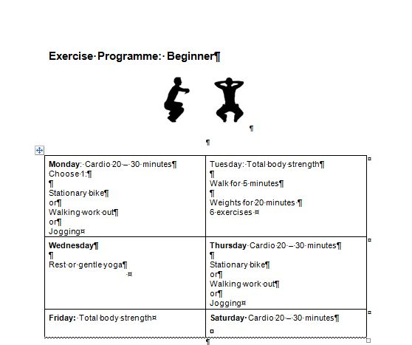1 | 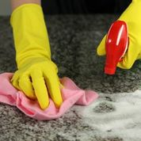 2
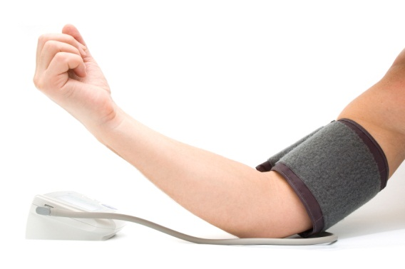3 |  4
5 | 6
 7 | 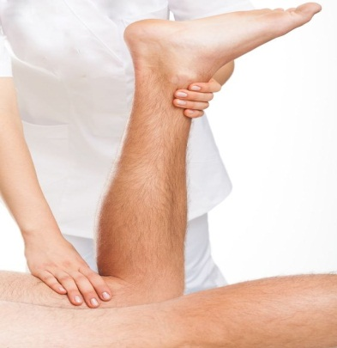 8

Resource 1b The instructor’s role
fill out forms | health checks
clean equipment | referee
repair equipment | massage
personal training | write programmes

Resource 2 Health induction questions
A 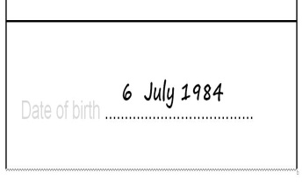 | 1. What’s your name?
 | 2. What’s your date of birth?
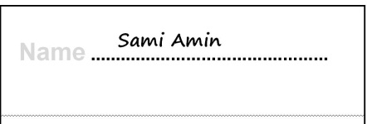  C | 3. How tall are you?
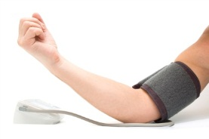  D | 4. How much do you weigh?
E 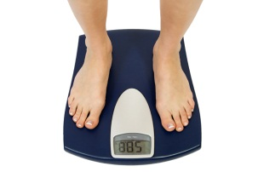 | 5. Are you on medication?
F | 6. Do you smoke?
G  | 7. Do you have chest pains?
 | 8. Do you have high blood pressure?

Resource 3 PAR-Q form
Name ...............................................
Date of birth .....................................
Height ..............................................
Weight .............................................
Medication .......................................
Do you smoke? ………………………….
Do you ever have chest pains?.............
Do you have high blood pressure?........

Resource 4 Exercises and equipment
1 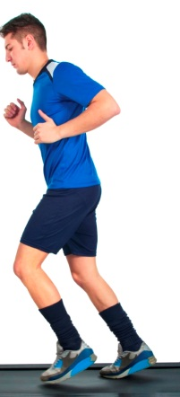 | 2 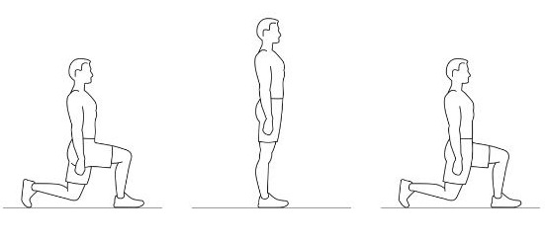
3  | 4 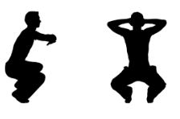
5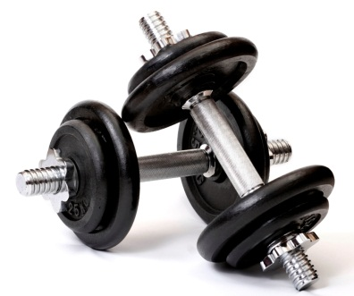  weights | 6 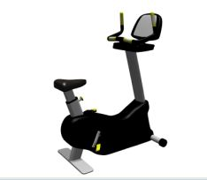  exercise bike
7 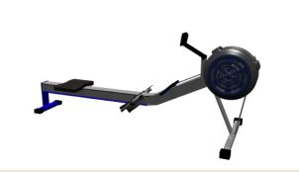  rower | 8 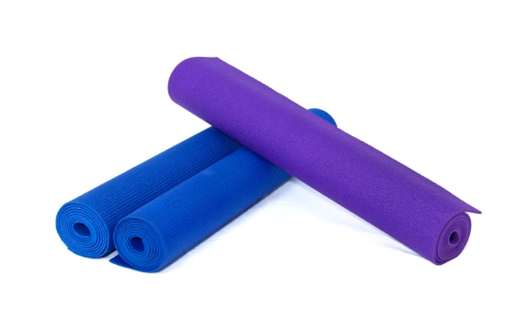  mats

